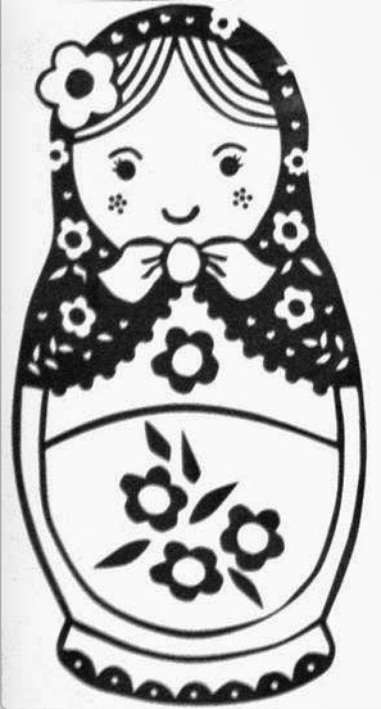

# Matryoksha doll:
to solve this we need to know what is matryoksha doll.
- Then download the image and in terminal run this code:
$ binwalk imagename.jpp

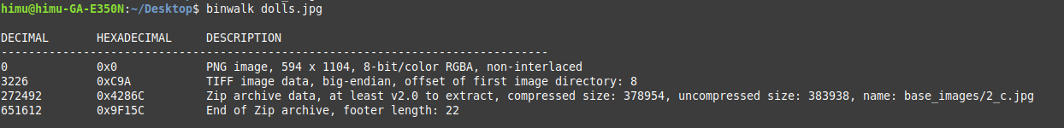
we get this out put from the code. Here we can see a zip. It could be 3000 zip in it. So unzip every zip file is very time consuming to avoid this problem we write a code

now we have to do this

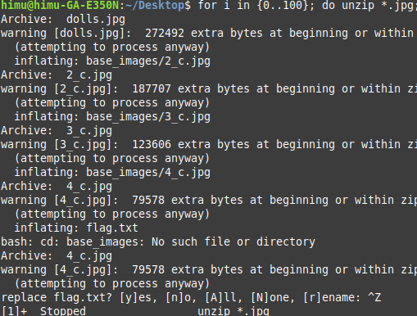
now pressing ctrl+z and type $ ls
this will give us 2 files.
To open the txt file type $ cat txtfilename.txt
the flag is : picoCTF{bf6acf878dcbd752f4721e41b1b1b66b}

